CO3 AT2
NAME:HA.HARSHAVARDHAN
REGNO:192511171
SUB:CSA1501 CLOUD COMPUTING

Case Study 3: Online Food Ordering Platform
A startup builds a cloud-based food ordering system accessible via web browsers and mobile clients.
Frontend clients interact with backend services through RESTful Web APIs hosted on a cloud
platform.
Cloud storage is used to store menu images, invoices, and customer data securely. The infrastructure

uses virtual machines and managed Kubernetes for scalability and reliability. Security is enforced
through authentication tokens, HTTPS, and role-based access control. The system demonstrates
integration of clients, APIs, storage, and platform services in real time.
Architecture Diagram

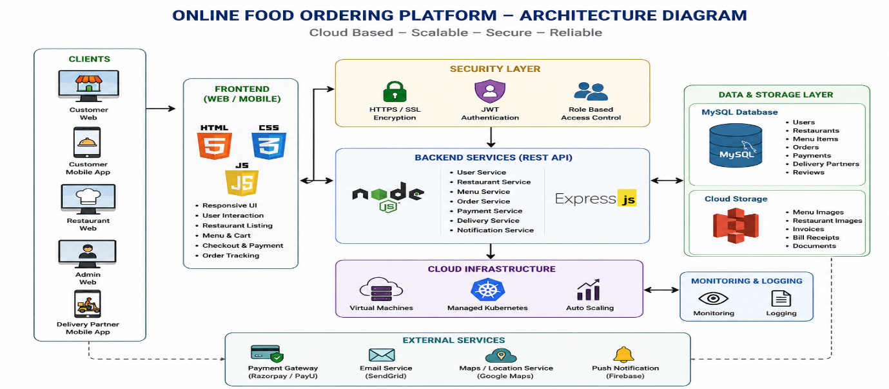
WEB PAGE RESULT:
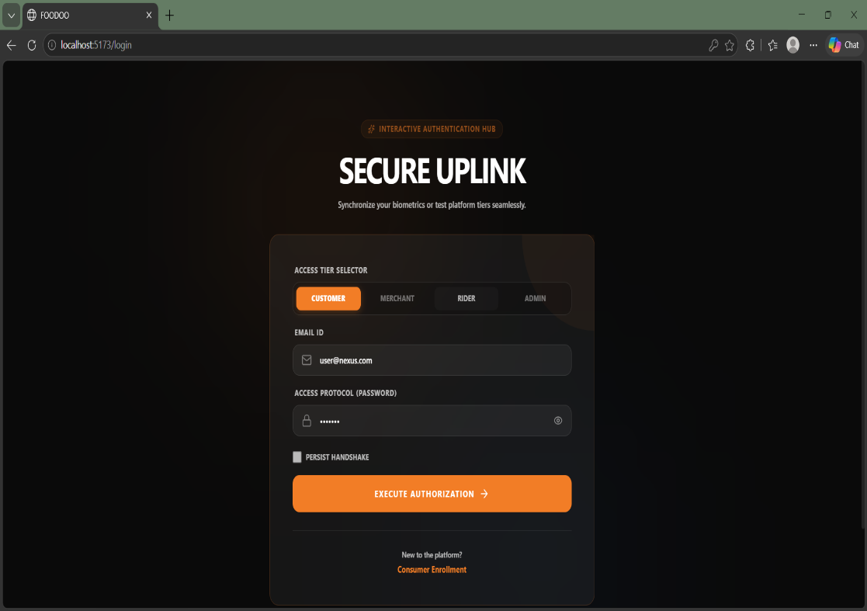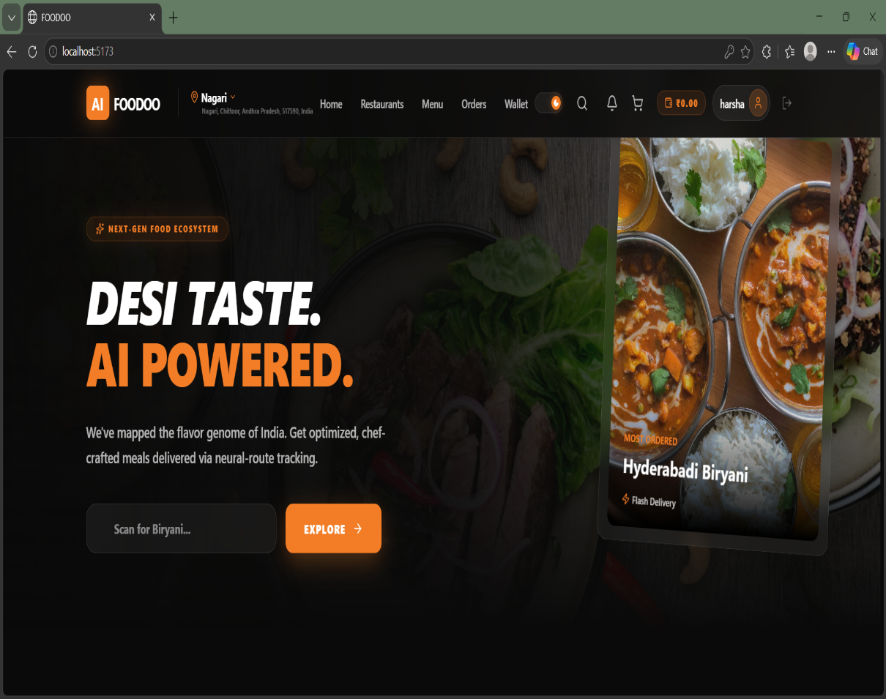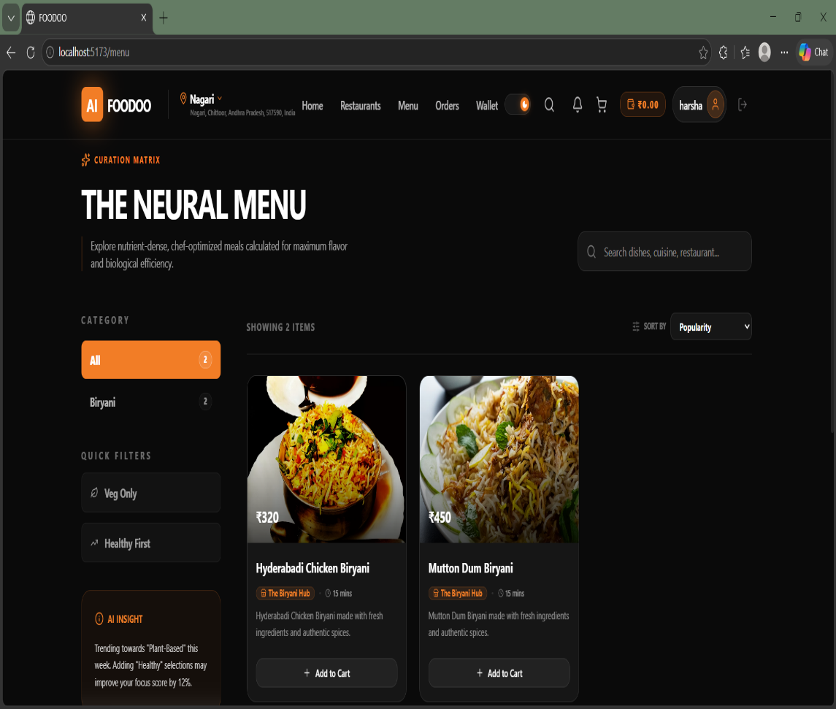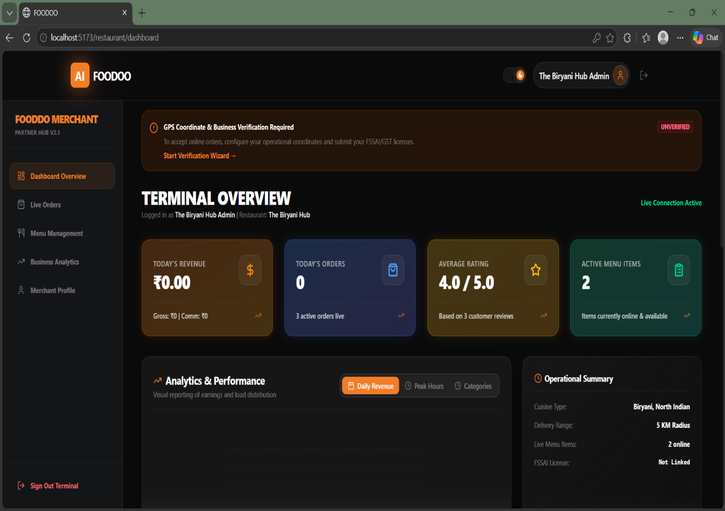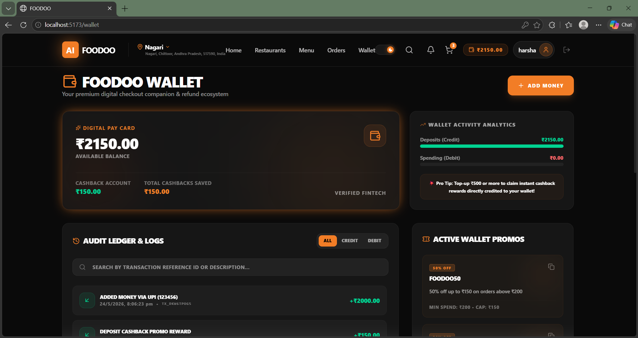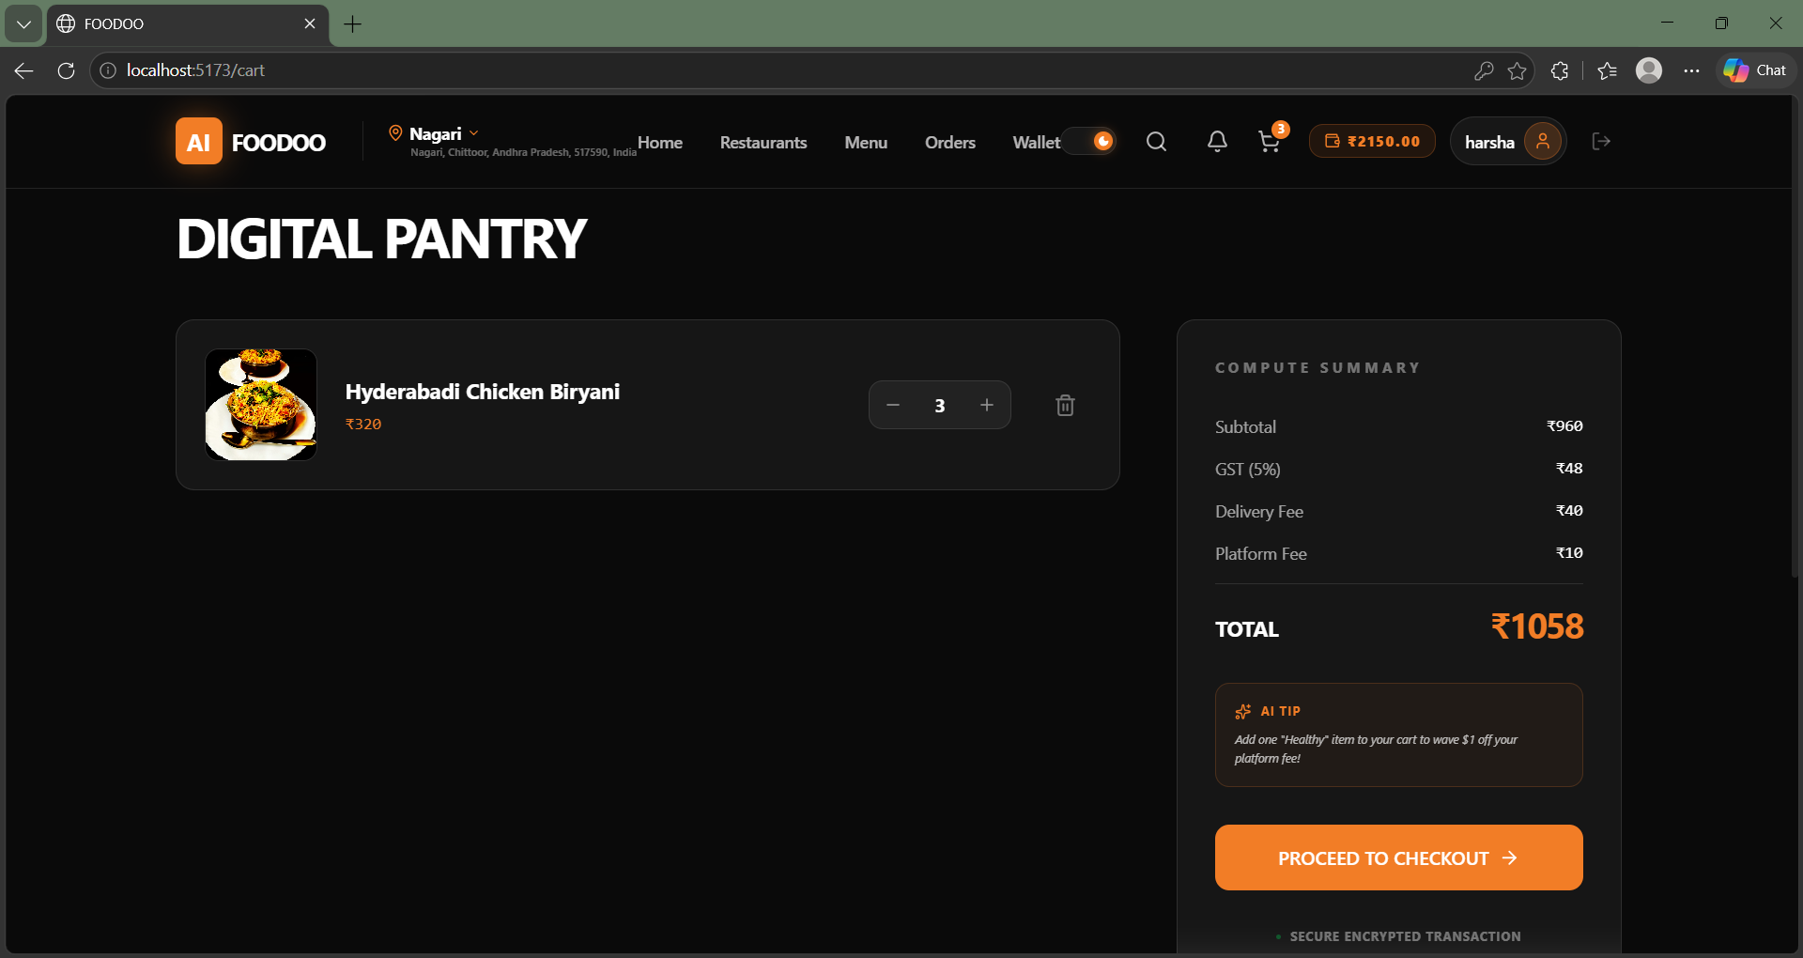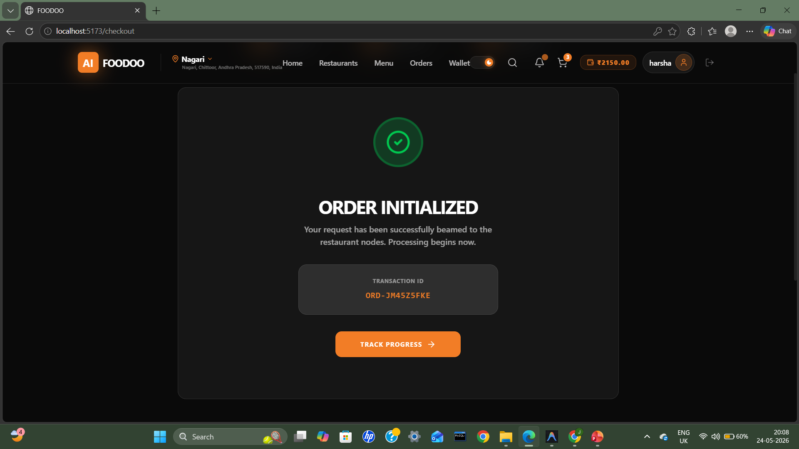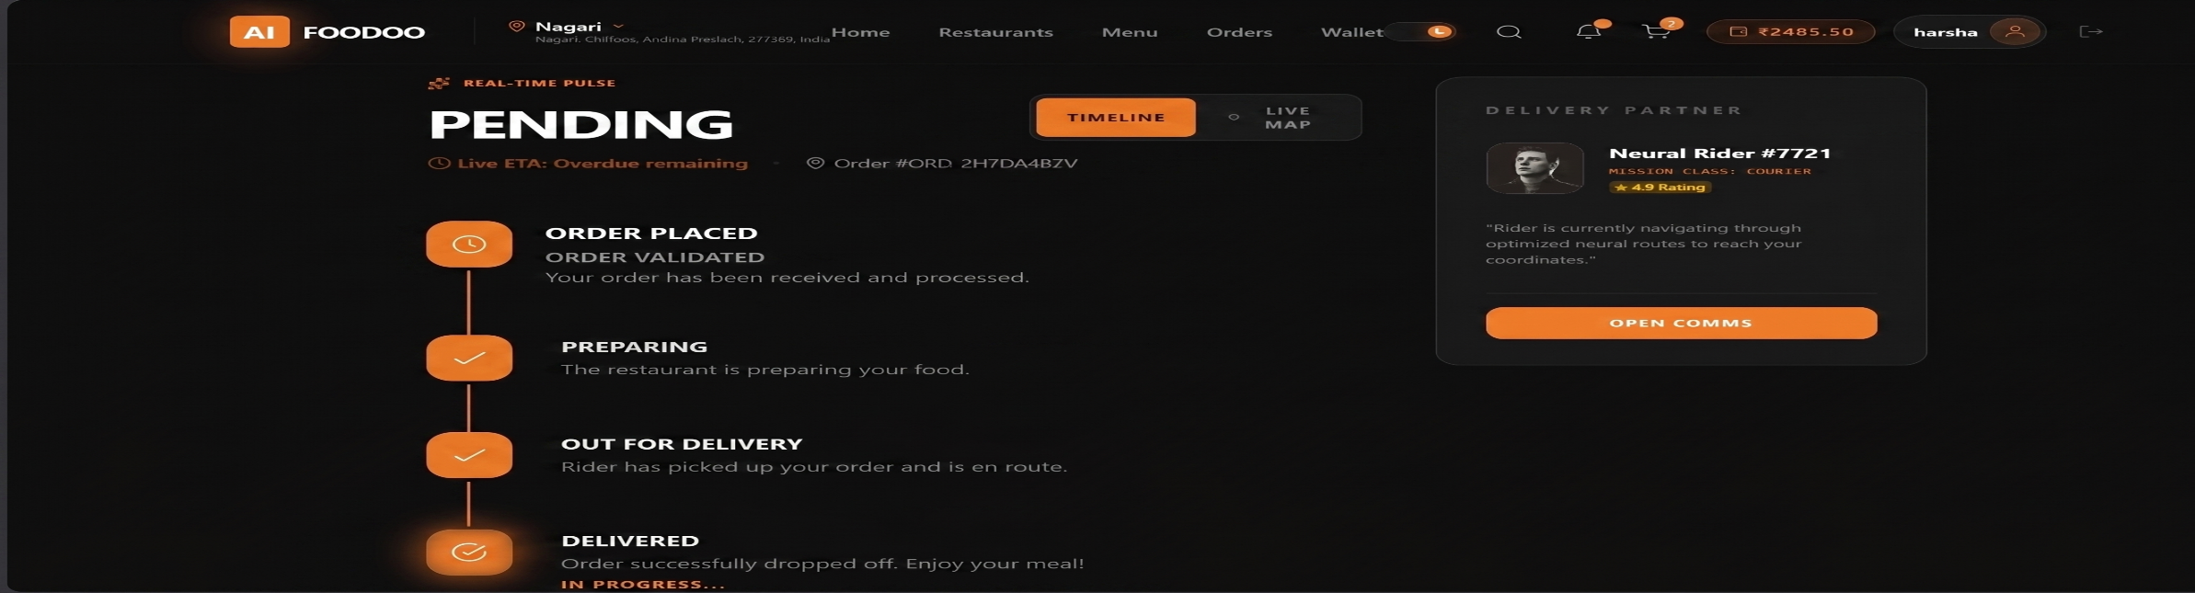

FLOW CHART:
